WITHINGTON WHEELERS 

OPEN 10 MILE TIME-TRIAL, J2/3 Course
Saturday 31st August 2019 14.01 Start
PROMOTED FOR AND ON BEHALF OF CYCLING TIME TRIALS UNDER THEIR RULES AND REGULATIONS.
Headquarters: Goostry Village Hall
Main Rd, Goostrey, Crewe CW4 8PE

Please allow 10 minutes to get to the start from the HQ. Leave the HQ, turn left on to Main road. 1.5km to Hermitage lane left here and continue to end of road. Total distance 1.65 miles

COURSE J 2/3 10 miles
START in Twemlow Lane at a "JS4" mark just east of Hermitage Lane in line with the hedge on Hermitage Lane. Proceed eastwards to the A535 at
TWEMLOW GREEN 1.047 m. Left onto the A535 and continue along here to Chelford Island 5.661m. Encircle the island and return along the A535 at and finish at “JF4” mark by the far post of the last field gate on the left of A535 at Twemlow Green before the Yellow Broom Restaurant
NO U TURNS IN SIGHT OF THE START AND FINISH AREA PLEASE AND ALWAYS RIDE WITH YOUR HEAD UP.

Race Numbers
These will be available at the HQ from 12.30 pm. Please return them after the event and sign out or you will be disqualified.

Prizes One rider one prize, except for the team award.
Prizes will be sent out by post in the week following the event.
First £20 | 1st Female £20
Second £15 | 2nd Female £15
Third £12.50 | 3rd Female £12.50
Fourth £10 | 4th Female £10
 | Fastest Team £10 x 3
Fastest Vet on Standard £15  2nd Vet on Standard £10 | 1st vet Female £15  2nd Vet Female £10
First Junior £10
First Juvenile £10

Care at Road Junctions: Riders must exercise care at all junctions. Any competitor who’s riding line causes him/her to cross the white line when approaching or leaving a junction will be liable to disqualification from the event and may be reported to the District Committee for further disciplinary action.
Chelford Island: Riders must negotiate Chelford Island in a safe and sensible manner in accordance with CTT Reg. 20 and the rules of the road. Riders must be able to brake and stop at the Island if traffic conditions require this. Riders must not approach and encircle the island using tri-bars. Remember – traffic on the island has priority over traffic (including riders) entering it. Any riders seen in breach of this regulation will be disqualified from the event and may be reported for further disciplinary action.
Chelford Island: in wet weather beware of slippery surface.
In the interests of your own safety – Cycling Time Trials and the event promoters strongly advise you wear a hard shell helmet that meets an internationally accepted safety standard. In accordance with Reg.15 all junior competitors MUST wear protective hard shell helmets.
It is recommended that a working rear light, either flashing or constant, is fitted to the machine in a position visible to following road users and is active while the machine is in use.

Time keepers: Martin Jackson and Graham Lawrence

Event Secretary: Paul Ekgren, 12 Lodgeside Close, Droylsden, Manchester, M43 7QZ.
Tel: 07456 841594
bib | start time | first name | last name | club | gender | category
1 | 14:01 | Vic | Trigger | Crewe Clarion Whs | Male | Veteran
2 | 14:02 | Simon | Bytheway | Rochdale Tri Club | Male | Veteran
3 | 14:03 | Andy | Riley | ABC Centreville | Male | Veteran
4 | 14:04 | Derek | Black | Wigan Whs CC | Male | Veteran
5 | 14:05 | Syd | Brown | Innovation Racing | Male | Junior
6 | 14:06 | Austin | Foy | North Lancashire Road Club | Male | Veteran
7 | 14:07 | Derek | Hodgins | Stockport Clarion CC | Male | Veteran
8 | 14:08 | Lynsey | Astles | Weaver Valley CC | Female | Veteran
9 | 14:09 | Kevin | Blades | Team Lusso | Male | Veteran
10 | 14:10 | Nigel | Wood | Seamons CC | Male | Veteran
11 | 14:11 | Lydia | Yates | Velo Karbona | Female | Senior
12 | 14:12 | George | Aldridge | Birkenhead North End CC | Male | Veteran
13 | 14:13 | Mike | Daniels | Velo Karbona | Male | Veteran
14 | 14:14 | Damian | Ellis | Leek CC - Den Engel Belgian Bar | Male | Veteran
15 | 14:15 | Andrew | Greenhalgh | Team ASL-Bolton | Male | Veteran
16 | 14:16 | Warren | Jackson | Congleton CC | Male | Veteran
17 | 14:17 | John | Leach | Rossendale RC | Male | Veteran
18 | 14:18 | Kenneth | Trigger | Crewe Clarion Whs | Male | Veteran
19 | 14:19 | Kirsten | Osborn | Macclesfield Wheelers | Female | Senior
20 | 14:20 | Alexander | Royle | Manchester Bicycle Club | Male | Senior
21 | 14:21 | John | Spearman | Seamons CC | Male | Veteran
22 | 14:22 | Duncan | Poole | Congleton CC | Male | Veteran
23 | 14:23 | Sam | Kelly | East Lancashire RC | Male | Juvenile
24 | 14:24 | Alan | Roberts | Stone Wheelers CC | Male | Veteran
25 | 14:25 | Chris | Southworth | Leigh Premier Road Club | Male | Veteran
26 | 14:26 | Kelvin | Milward | Congleton CC | Male | Veteran
27 | 14:27 | Chris | Wilcox | Lyme Racing Club | Male | Veteran
28 | 14:28 | Tony | Perrin | Stone Wheelers CC | Male | Veteran
29 | 14:29 | Chris | Fell07 | Crewe Clarion Whs | Male | Veteran
30 | 14:30 | Paul | Grindley | Liverpool Century RC | Male | Veteran
31 | 14:31 | Paul | Whittaker | Stockport Clarion CC | Male | Veteran
32 | 14:32 | Emily | Martin | Weaver Valley CC | Female | Senior
33 | 14:33 | Andy | Cummings | Warrington Triathlon Club | Male | Veteran
34 | 14:34 | Carol | Robson | Weaver Valley CC | Female | Veteran
35 | 14:35 | Tristan | Pilling | Middleton CC | Male | Junior
36 | 14:36 | Dave | Curran | Weaver Valley CC | Male | Veteran
37 | 14:37 | Michelle | Fairclough | Salford Cycling Club | Female | Veteran
38 | 14:38 | Steve | Mcquade | Crewe Clarion Whs | Male | Veteran
39 | 14:39 | Cyril | Wynne | Stretford Wheelers CC | Male | Veteran
40 | 14:40 | Ben | Stead | ABC Centreville | Male | Senior
41 | 14:41 | Matthew | Last | Trinity Cycling Team | Male | Senior
42 | 14:42 | Stephen | Sladin | Congleton CC | Male | Veteran
43 | 14:43 | David | Wilson | Eat Plants Not Pigs CC | Male | Veteran
44 | 14:44 | Bill | Renard | Macclesfield Wheelers | Male | Veteran
45 | 14:45 | Claire | Harrison | Pro Vision Cycle Clothing | Female | Veteran
46 | 14:46 | Barry | Armstrong | Seamons CC | Male | Veteran
47 | 14:47 | Harry | Wilson | Innovation Racing | Male | Juvenile
48 | 14:48 | Nick | Howl | Warrington Road Club/Horton Light Engineering/RS Cyclesport | Male | Veteran
49 | 14:49 | Richard | Cordin | Matlock CC | Male | Veteran
50 | 14:50 | Adrian | Hughes | Seamons CC | Male | Veteran
51 | 14:51 | Kevin | Woodward | Salford Cycling Club | Male | Veteran
52 | 14:52 | William | Howarth | East Lancashire RC | Male | Veteran
53 | 14:53 | Lynne | Ewington | Velo Karbona | Female | Veteran
54 | 14:54 | Tobias | Edwards | Huddersfield Star Whs | Male | Espoir
55 | 14:05 | Stephen | Turner | Westmead Team 88 | Male | Veteran
56 | 14:56 | Andy | Whitehead | Seamons CC | Male | Veteran
57 | 14:57 | Janet | Grint | Stockport Tri Club | Female | Veteran
58 | 14:58 | Lesley | Norbury | Congleton CC | Female | Veteran
59 | 14:59 | Lee | Winslow | SKCC | Male | Veteran
60 | 15:00 | Darren | Maironis | Transition Race Team | Male | Veteran
61 | 15:01 | Dan | Robson | Weaver Valley CC | Male | Veteran
62 | 15:02 | Peter | Howarth | Stretford Wheelers CC | Male | Veteran
63 | 15:03 | Anna | Brunt | Seamons CC | Female | Veteran
64 | 15:04 | Steven | Hazeldine | Stone Wheelers CC | Male | Veteran
65 | 15:05 | Rufus | Brunt | Seamons CC | Male | Veteran
66 | 15:06 | Sam | Taylor | Weaver Valley CC | Male | Senior

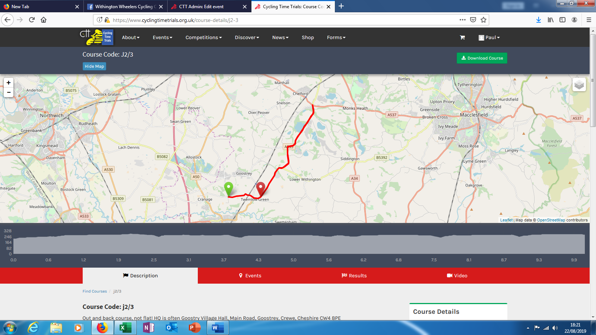

Alternate course if unable to use J2/3 due to Twewlow Lane being flooded. Astle Park to Booths hall roundabout and return.

